Sep 27, 2026
Lecture #1: Fundamentals of Testing
- Difference between QA, QC, and Tester in the software process
- QA is a process-oriented (preventive approach). Focus on implementation and improvement of process  - QC is a product-oriented (model checking, proof of correctness), simulation, and prototype. Focus on process running as expected  - Testing is a part of QC and supports the goals of quality level  - Testers aim to find failures by breaking software | 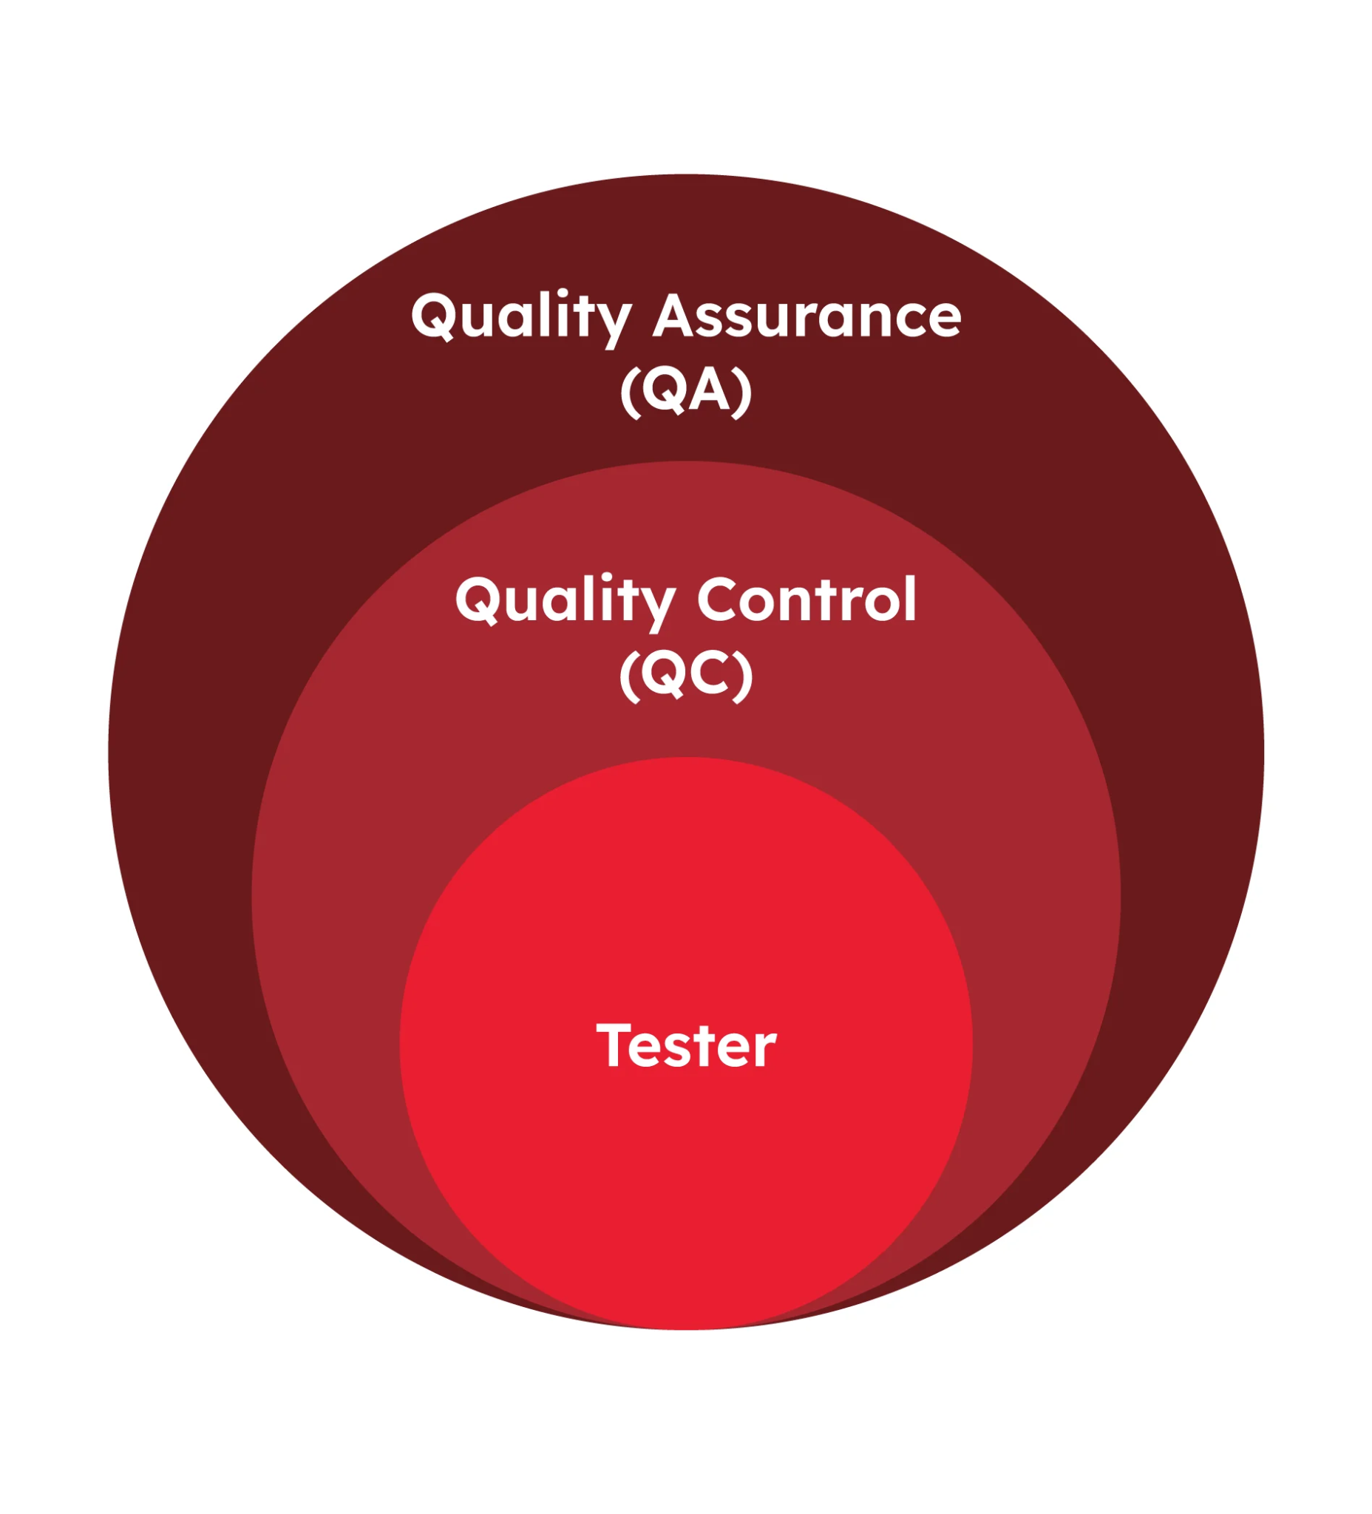

- Distinguish between error, defect, and failure
- Errors: mistake made by humans that create an incorrect result  - Defects: an error in the software, maybe an error in the code, analysis requirements, or design architecture (documentation/technical things)  - Failure: misbehaves during execution, causing the product to crash, wrong result, or not meet the requirement or system ==> not all defects may always cause failures  - Root cause: a fundamental reason for the occurrence of a problem | 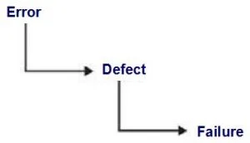  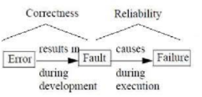

- Testing Principles (7 principles)
- Test activity
Test activity | What happens
Test planning | Define scope, strategy, resources
Test monitoring & control | Track progress and adjust plans
Test analysis | Identify what to test
Test design | Design test cases and test data

- Test process and Testware
- Test process: help fulfill stakeholders' business needs (exhaustive and risk-based testing)
- Testware: create as output work products from the test activites
 | Test process | Testware
Definition | A structured set of activities carried out during testing | All artifacts produced or used during the test process
Focus | How testing is done → activities & workflow | What is created or used during testing → documents, tools, data
Purpose | To organize and manage testing | To support, document, and execute the testing process
Example | Testing planning, analysis execution, closure | Test cases, test data, test scripts, defect reports, traceablitity
Reusability | Process is followed again, but not reused as-is | Testware is reusable and maintainable across test cycles
Who uses it | Followed by the entire test team | Created/used by testers, dev, QA
- Traceability purpose
- Traceability of test case - requirement: verify the requirements are covered by test cases
- Traceability of matrix: map test cases—corresponding requirements/design elements
- Traceability of test results-risks: level of residual risk in a test object
- Verification and Validation
- Verification: checking whether the system meets specified requirements + assess quality
- Validation: checking whether the system meets users' and other stakeholders' needs in its operational environment

Sep 28, 2026
Lecture #2: SDLC and SDTC

- Testing in the Context of a Software Development Lifecycle
Software development activities | Software test activities
- Activities performed in a software development project  - These depend on the SDLC method | - For every development activity, there is a corresponding test activity  - Each test level has specific objectives for that level  - Test analysis and design begin corresponding to the development activity  - Testers take part in discussions to define and refine requirements and design

 | TDD | ATDD | BDD
Focus | Code functionality | Acceptance critearia | System behaviour (functional level)
Language | Code-based | Natural language or structured | Gerkin (natural language)  - Given... When... Then" format
Participants | Only Dev | Business + Tester + Dev | Busniness + Tester + Dev

- DevOps vs. Testing
 | DevOps | Testing
Main goal | Deliver software faster and more reliably | Find defects and evaluate quality
Focus | Collaboration, automation, continuous delivery and deployment | Defect detection, verification and validation
Activities | CI/CD pipelines, infrastructure automation, monitoring and deployment | Test planning, test design, execution and defect reporting
Outcome | Faster, more reliable software delivery | Information about software quality and risks

- Test level: Groups of test activities that are organized and managed together
- Unit test →  - Test object: Components (smallest units of software)  - Typical defect: Incorrect functionality, data flow problems,...  - Test basis: Code, detailed design  - Technique: White box testing  - Integration test  - Test object: Database, API,... (test the interfaces and interactions between component)  - Typical defect: Incorrect data, interface mismatch  - System test  - Test object: Applications, operating systems  - Typical defect: Incorrect or unexpected system behaviour,...  - Test basic: SRS, Risk analysis reports  - Technique: Black box testing  - Acceptance test  - Test object: Backup and restore, non-functional requirement  - Typical defect: System workflow doesn’t meet business requirements, incorrect business rules, system doesn’t satisfy regulation,..  - Technique: Black box testing | 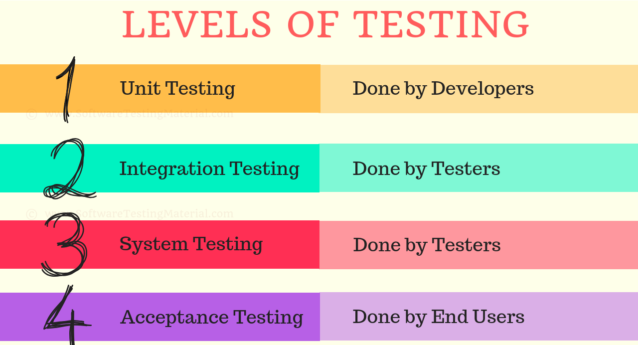

- Test type: different categories of testing that focus on what aspect of software is being tested
- Functional testing:
- Test which evaluates functions that the system should perform
- Test what the system/test object should do
- Non-functional:
- Evaluates usability, performance, security
- Test how the system does its job
- Black-box testing:
- Checking the system behavior against its specifications
- White-box testing
- Evaluates code, architecture, workflows, and data flow within the system. Give a percentage of coverage
- Confirmation testing and regression testing
- Confirmation testing: testing that runs the same test cases that failed earlier to confirm that the failure has been fixed
- Regression testing: testing that make sure the new changes (like bug fixed or enhancements) haven’t broken existing functionalities
- Maintenance
- Modification: Changes made to the software system
- Corrections: fixing defects or bugs identified in the operational system
- Enhancements: Adding new feature or improving existing ones (part of planned release or unplanned hotfixes)
- Adaptions: Changes needed due to alterations in the operational environment
- Migration:
- Moving the software system from one platform or environment to another
- This necessitates testing in the new environment.

Sep 30, 2026
Lecture #3+4: Static Testing
- Static Testing Basics
- A method of software testing where the - code is not executed
- Code, documentation or other work products are examined by reviewing by humans or using tools to find defects
- Static vs Dynamic Testing
 | Static testing | Dynamic testing
Code Execution | No execution required | Code must be executed
When Performed | Early in SDLC | After code is written
What is Tested | Code, documents, specs | Running software/system
Methods | Reviews, walkthroughs, static analysis tools | Test execution using tools or manual efforts
Defect Types Found | Syntax errors, design flaws, standard violations | Runtime errors, functional bugs, performance issues
Cost of Fixing | Lower (issues found early) | Higher (issues found later in cycle)
Focus | Structure, consistency, and correctness | Behavior, output, and user interaction
Involvement | Manual review by developers/testers, automated tools | Mostly automated tools, manual test case execution

- Feedback and Review Process
Activity | Review
Planning | - Identify what will be reviewed (work product) and why  - Define objectives (e.g., finding defects, improving quality)  - Select participants (reviewers, moderators, authors, etc.)  - Allocate roles and responsibilities, effort, timeframes for review  - Schedule review meetings (if needed)  - Prepare necessary materials for the review
Initiation | - The author (person who created the work product) distributes the work product to the reviewers  - Reviewers receive relevant instructions and background material  - Everyone gets ready for the review by understanding the purpose and context
Individual Review | - Checklist-based reviewing, scenario-based reviewing  - Reviewers identify defects, issues, or improvement suggestions  - Review techniques can be used (like checklists, rules, or ad-hoc reading)

- Review type:
 | Formality | Key feature | Participants
1. Formal review | Low | - No formal process  - Main objectives is detecting anomalies | Author + 1 or more peers
2. Walkthrough | Medium | - Author explains | Author-led, reviewers ask question (perfors individual task)
3. Technical review | Medium-High | - Focus on technical content | Peer with technical expertise
4. Inspection | High | - Formal roles, checklists, metrics  - The main objective is to find the maximum number of anomalies. | Moderator, Author, Reviewers, Scribe (author can’t act as review leader or scribe)

- Test Techniques Overview
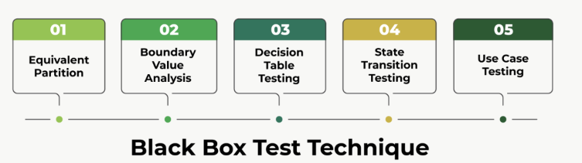
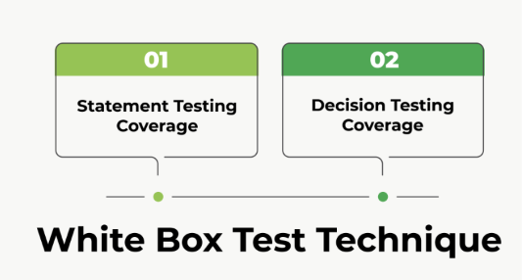
Statement Testing & Coverage: focus on executable statement is implement at least once
Decision Testing & Coverage: focus on test case coverage the control flows occurring from a decision point at least once

- Error Guessing:  +  - Exploratory testing : Session based testing  - Tests are simultaneously designed, executed and evaluated while the tester learns about the test objects  - Tester uses test charter containing test objectives(High level test conditions) to guide testing  - Test session is involves discussion with tester and stakeholders  - Checklist-base testing  - Testers design, implement and execute tests to cover test conditions found in a checklist  - The results are then analysed to build new checklists or expand an existing one  - The checklists are build based on past experience  - These checklists are often high level, allowing for greater coverage but less reproducibility | 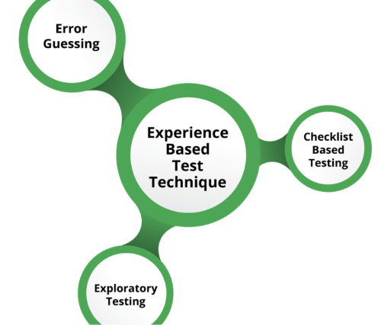

Oct 3, 2026
Lecture #5: Managing the Test Activities
- Identify the tasks of a test manager and tester
- Test manager has overall responsibility for the test process:
- Develop test policy/strategy
- Consider context and risk
- Select ‘test approach’
- Estimate test time and cost
- Acquire resources
- Write the test plan
- Progress reports, summaries
- Decide about implementation of test environments
- Typical tester tasks may include:
- Review/contribute to test plans
- Assess requirements, user stories, test basis
- Document test conditions
- Execute tests, evaluate tests, document deviations
- Automate tests as needed
- Review tests developed by others
- Risks and Testing
Risk level = Likelihood * Impact
Risk level = Likelihood + Impact
Product risks
- Software not according to specification
- System architecture not adequate
- Response times are inadequate
Project risks
- Project issues
- Organizational issues
- Political issues
- Technical issues
Defect Management
- Defects should be logged
- Defects should be tracked from discovery to resolution
- Some reports may be false positives, which should be minimized.
- Defect reports should have information about adverse events
- They should provide a means for tracking the quality of work
- They may provide ideas for development and test process improvement

Oct 5, 2026
Lecture #6: Tools support for testing

- Objectives and support activities
- Automation of tests (test execution, regression)
- Support manual tests
- Improve test reproducibility
- Increase reliability
- Identify benefits and risks of test automation
- Reduction in manual work
- Greater consistency
- Static measures, coverage
- Time and cost may be underestimated
- Version control may be neglected
- Vendor may go out of business

